Normal distribution Worksheet

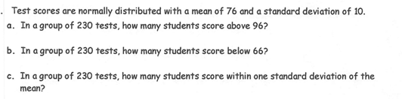

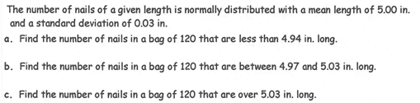

- 6.6.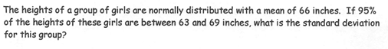

- 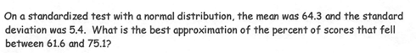
- 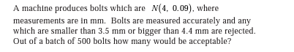
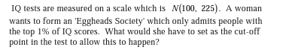
- The average number of acres burned by forest and range fires in a large New Mexico county is 4,300 acres per year, with a standard deviation of 750 acres. The distribution of the number of acres burned is normal.
- What is the probability that between 2,500 and 4,200 acres will be burned in any given year?
- What number of burnt acres corresponds to the 38th percentile?
- A line for tickets to a local concert had an average (mean) waiting time of 20 minutes with a standard deviation of 4 minutes. If 2000 ticket buyers were in line, how many of them would expect to wait for more than 30 minutes?

